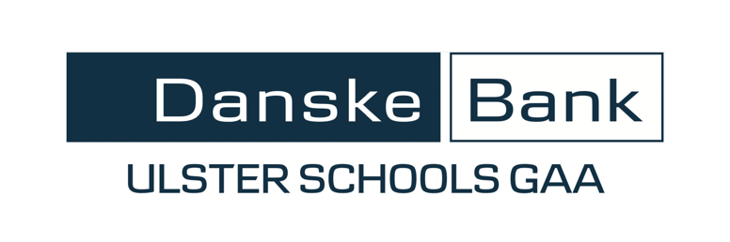
CLG SCOILEANNA ULADH
ULSTER SCHOOLS GAA

CRUINNIÚ CINN BLIANA 2023/24
ANNUAL GENERAL MEETING 2023/24

AINMNIÚCHÁIN
(Please confirm in advance that your nominee(s) is
(are) available and willing to serve if appointed)

POST  (Position) | AG DUL AS OIFIG  (Outgoing) | AINMNUÍCHÁN  (Nomination)
Leas-Chathaoirleach  (Vice Chairperson) | Paddy Linden
Leas-Rúnaí  (Assistant Secretary) | Martin McConnell
Cisteoirí  (Treasurer x2) | Sean McGourty  David Treanor
Oifigeach Caidreamh Poiblí  (Public Relations Officer) | Raff Gatt
IT Faisnéise  (IT Officer) | Mark Grogan
Ionadaí Comhairle Uladh  (Ulster Council Rep) | Garrett Coyle
Uachtarán Oinigh  (Honourary President) | Paraic Duffy

Delegates to All-Ireland Convention (8):

NB.
Bye-law 8 states that one of the functions of the AGM is to elect the 6 officerships above and an Honorary President.
Bye-law 4 (iii) states that “the committee of Scoileanna Uladh shall also consist of “not more than 13 Competition Coordinators”; these 13 will be co-opted as members of the incoming committee.

If you would be willing to volunteer as a competition coordinator, please contact
Carly McClean or Seamus Woods.

SIGNED: ___________________________________ (Head of PE/Gaelic games)

SCHOOL: ___________________________________

Returns should be made by 5ú Bealtaine 2023 via email to
carly.mcclean.ulster@gaa.ie AND seamusjwoods@gmail.com

